3 Basic transform

Translation

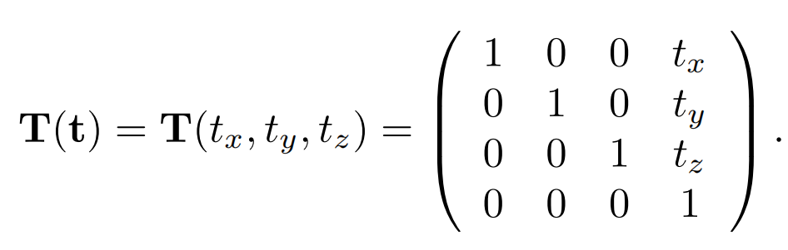

The inverse of a translation matrix is T-1(t) = T(-t),that is, the vector t is negated.

Rotation

Like a translation matrix, it is a rigid-body transform, i.e., it preserves the distances between points transformed, and preserves handedness (i.e., it never causes left and right to swap sides).

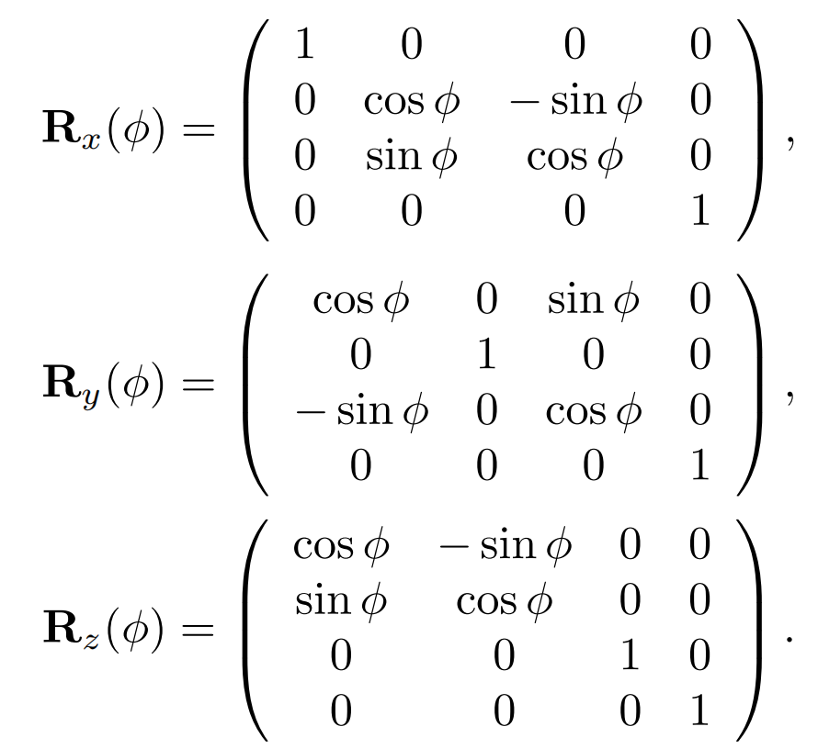

All rotation matrices have a determinant of one and are orthogonal. This also holds for concatenations of any number of these transforms. There is another way to obtain the inverse: Ri -1(φ) = Ri(-φ), i.e., rotate in the opposite direction around the same axis.

Assume that we want to rotate an object by φ radians around the z-axis, with the center of rotation being a certain point, p. What is the transform?

X = T(p)Rz(φ)T(-p).

Scaling

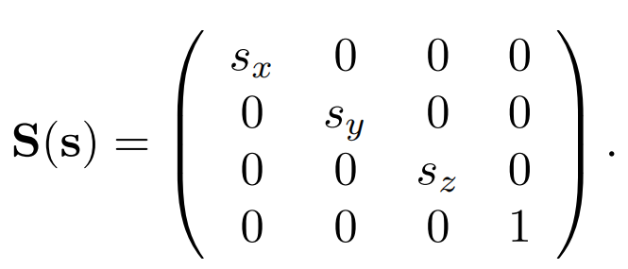

Concatenation of Transforms

The obvious reason to concatenate a sequence of matrices into a single one is to

gain efficiency.

TRS is the order commonly used by scene graph systems.

Normal Transform

Instead of multiplying by the matrix itself, the proper method is to use the transpose of the matrix’s adjoint [227]. Computation of the adjoint is described in our

online linear algebra appendix. The adjoint is always guaranteed to exist. The normal is not guaranteed to be of unit length after being transformed, so typically needs

to be normalized.

The traditional answer for transforming the normal is that the transpose of the

inverse is computed [1794].

Finally, fully renormalizing the normal produced is not always necessary. If only

translations and rotations are concatenated together, the normal will not change length

when transformed by the matrix, so no renormalizing is needed. If uniform scalings

are also concatenated, the overall scale factor (if known, or extracted—Section 4.2.3)

can be used to directly normalize the normals produced. For example, if we know

that a series of scalings were applied that makes the object 5.2 times larger, then

normals transformed directly by this matrix are renormalized by dividing them by

5.2.

Tangent vectors are different than normals in nature, and are

always directly transformed by the original matrix.